Manuscript Template (w.e.f. April 25 issue)

Title and Authors with affiliation and email:

Adsorption of Chromium (III), Nickel (II) and Copper (II) from Aqueous Solution by Activated Alumina
N.S.Rajurkar¹* , A.V. Gokarn² and K.Dimya²
1*. Chemistry Department, Pune University, Pune 411007, India
2. Environmental Science Department, Pune University, Pune 411007, India
Email: rnilima@rediffmail.com

Abstract:
Provide an abstract up to 300 words. It should briefly describe the objectives of the research, technique employed, and major results achieved and the conclusions. You should give special emphasis on novelty of your work.
Key words: Water analysis, ICPAES, Pune region

1. Introduction:

It basically deals with the introduction of the topic with review of the work in this field followed by scope of the work. The Introduction is NOT an extended version of the Abstract; never use the same sentences in both sections. The references¹ can be added at appropriate places in all sections as superscript on right side.

2. Materials and Methods:
Describe the experimental procedure precisely so that they could be reproduced by another researcher. Do not describe in detail the methods commonly used or already published, cite them instead. Describe in short, the sampling procedure if used for your analysis.
2.1 You can have sub-heading, if required

Results and Discussion:
In this section, your results and their interpretation should be given and appropriate mechanism, in case if needed, can be highlighted.
For equations, use the equation editor or Math Type. Number the equations consecutively. The equations should be placed centered, while their serial numbers should be given on the same line in parentheses aligned to the right. Refer to them in the text as Eq. (1).
A= abc (1)
3.1 Subsections under different headings can be added, if needed

Table 1: Table caption should be clear and concise
Parameter | Result/SI unit
Parameter 1 | 11.56 ± 0.03
Parameter 2 | 15.88 ± 0.05
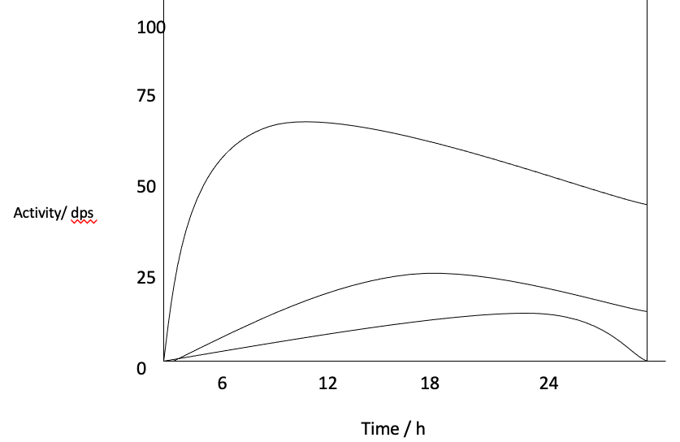
Fig.1: Write concise caption of figure
Photographs
Photographs should have a minimum resolution of 300 dpi. If any magnification is used in the photographs, indicate this by using scale bars within the figures themselves.
Insert the Figures, Tables, charts and Photographs at the appropriate places in the text
Conclusions
It should summarize the most important results, their novelty advantages, and limitations in 6-8 lines
Acknowledgement:
Acknowledgments of people, grants, funds, etc. should be placed here. The names of funding organizations should be written in full.
Authors’ Contributions: Precisely write role of each author in planning the work, conducting experiments, interpretation of results, writing the manuscript etc.
Conflict of Interest: Specify the conflict of interest, if any.

References:

Journal article:

Atomic Spectroscopy
Vol. 40(4), July / August 2019
*Corresponding author.
E-mail: arijita@barc.gov.in
:
ICP-AES Characterization of PHWR
Irradiated Thoria Bundles for Fission Products
A. Sengupta, B. Rajeswari, V. C. Adya and R. M. Kadam, “ICP-AES Characterization of PHWR Irradiated Thoria Bundles for Fission Products” Atom. Spect., 40(4), 127 -132, 2019.
Book name:
H. J. Arnikar, Essentials of Nuclear Chemistry, Wiley Eastern Limited, edn. 4 (1995).

Proceedings:
S. Kantak, T. Nesari and N. Rajurkar, The analysis of synthesized copper bhasma using neutron activation analysis technique, Proceedings of Fifth Symposium on Nuclear Analytical Chemistry (NAC-V) held at BARC, Mumbai, pp. 196-197 , Jan. 2014.

